
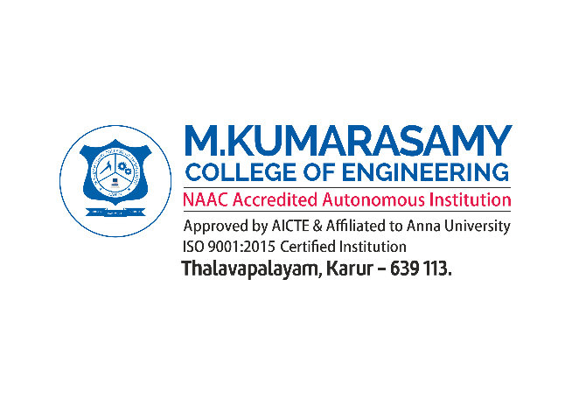
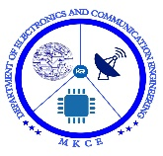
Design and development of Advanced Acoustic Metamaterials for tackling tinnitus and Urban Noise mitigations

A MINOR PROJECT - IV REPORT

Submitted by

SIVARAMAKRISHNAN M | 927621BEC201
SHANJAY R K | 927621BEC195
VISHWA S | 927621BEC243
SUBASH P | 927621BEC213

BACHELOR OF ENGINEERING
in
DEPARTMENT OF ELECTRONICS AND COMMUNICATION ENGINEERING

M.KUMARASAMY COLLEGE OF ENGINEERING
(Autonomous)

KARUR – 639 113

MAY 2024
M.KUMARASAMY COLLEGE OF ENGINEERING, KARUR
BONAFIDE CERTIFICATE
Certified that this 18ECP106L - Minor Project - IV report “DESIGN AND DEVELOPMENT OF ADVANCED ACOUSTIC METAMATERIALS FOR TACKLING TINNITUS AND URBAN NOISE MITIGATIONS ”is the bonafide work of “ SIVARAMAKRISHNAN M (927621BEC201), SHANJAY R K (927621BEC195), VISHWA S (927621BEC243), SUBASH P (927621BEC213) who carried out the project work under my supervision in the academic year 2023 -2024 - EVEN SEMESTER.

SIGNATURE SIGNATURE
Dr.A.KAVITHA B.E., M.E., Ph.D., JEYAKUMAR P B.E., M.E., Ph.D,
HEAD OF THE DEPARTMENT, SUPERVISOR ,
Professor, Assistant Professor,
Department of Electronics and Department of Electronics and
Communication Engineering, Communication Engineering,
M.Kumarasamy College of Engineering, M.Kumarasamy College of Engineering, Thalavapalayam, Thalavapalayam,
Karur-639113. Karur-639113.

This report has been submitted for the 18ECP106L – Minor Project - IV final review held at M. Kumarasamy College of Engineering, Karur on ____________________

PROJECT COORDINATOR

INSTITUTION VISION AND MISSION
Vision
To emerge as a leader among the top institutions in the field of technical education.

Mission

M1: Produce smart technocrats with empirical knowledge who can surmount the global challenges.
M2: Create a diverse, fully -engaged, learner -centric campus environment to provide quality education to the students.
M3: Maintain mutually beneficial partnerships with our alumni, industry and professional associations

DEPARTMENT VISION, MISSION, PEO, PO AND PSO
Vision
To empower the Electronics and Communication Engineering students with emerging technologies, professionalism, innovative research and social responsibility.
Mission
M1: Attain the academic excellence through innovative teaching learning process, research areas & laboratories and Consultancy projects.
M2: Inculcate the students in problem solving and lifelong learning ability.
M3: Provide entrepreneurial skills and leadership qualities.
M4: Render the technical knowledge and skills of faculty members.

Program Educational Objectives
PEO1: Core Competence: Graduates will have a successful career in academia or industry associated with Electronics and Communication Engineering
PEO2: Professionalism: Graduates will provide feasible solutions for the challenging problems through comprehensive research and innovation in the allied areas of Electronics and Communication Engineering.
PEO3: Lifelong Learning: Graduates will contribute to the social needs through lifelong learning, practicing professional ethics and leadership quality
Program Outcomes
PO 1: Engineering knowledge: Apply the knowledge of mathematics, science, engineering fundamentals, and an engineering specialization to the solution of complex engineering problems.
PO 2: Problem analysis: Identify, formulate, review research literature, and analyze complex engineering problems reaching substantiated conclusions using first principles of mathematics, natural sciences, and engineering sciences.
PO 3: Design/development of solutions: Design solutions for complex engineering problems and design system components or processes that meet the specified needs with appropriate consideration for the public health and safety, and the cultural, societal, and environmental considerations.
PO 4: Conduct investigations of complex problems: Use research-based knowledge and research methods including design of experiments, analysis and interpretation of data, and synthesis of the information to provide valid conclusions.
PO 5: Modern tool usage: Create, select, and apply appropriate techniques, resources, and modern engineering and IT tools including prediction and modeling to complex engineering activities with an understanding of the limitations.
PO 6: The engineer and society: Apply reasoning informed by the contextual knowledge to assess societal, health, safety, legal and cultural issues and the consequent responsibilities relevant to the professional engineering practice.
PO 7: Environment and sustainability: Understand the impact of the professional engineering solutions in societal and environmental contexts, and demonstrate the knowledge of, and need for sustainable development.
PO 8: Ethics: Apply ethical principles and commit to professional ethics and responsibilities and norms of the engineering practice.
PO 9: Individual and team work: Function effectively as an individual, and as a member or leader in diverse teams, and in multidisciplinary settings.
PO 10: Communication: Communicate effectively on complex engineering activities with the engineering community and with society at large, such as, being able to comprehend and write effective reports and design documentation, make effective presentations, and give and receive clear instructions.
PO 11: Project management and finance: Demonstrate knowledge and understanding of the engineering and management principles and apply these to one’s own work, as a member and leader in a team, to manage projects and in multidisciplinary environments.
PO 12: Life-long learning: Recognize the need for, and have the preparation and ability to engage in independent and life-long learning in the broadest context of technological change.

Program Specific Outcomes
PSO1: Applying knowledge in various areas, like Electronics, Communications, Signal processing, VLSI, Embedded systems etc., in the design and implementation of Engineering application.
PSO2: Able to solve complex problems in Electronics and Communication Engineering with analytical and managerial skills either independently or in team using latest hardware and software tools to fulfil the industrial expectations.

Abstract | Matching with POs, PSOs
<<Abstract keywords>> | PO1, PO2, PO3, PO4, PO5, PO6, PO7, PO8, PO9, PO10, PO11, PO12, PSO1, PSO2

ACKNOWLEDGEMENT

Our sincere thanks to Thiru.M.Kumarasamy, Chairman and Dr.K.Ramakrishnan, Secretary of M.Kumarasamy College of Engineering for providing extraordinary infrastructure, which helped us to complete this project in time.

It is a great privilege for us to express our gratitude to Dr.B.S.Murugan., B.Tech., M.Tech., Ph.D., Principal for providing us right ambiance to carry out this project work.

We would like to thank Dr.A.Kavitha, B.E., M.E., Ph.D., Professor and Head, Department of Electronics and Communication Engineering for his unwavering moral support and constant encouragement towards the completion of this project work.
We offer our wholehearted thanks to our Project Supervisor, Jeyakumar P, B.E., M.E., Ph.D, Assistant Professor , Department of Electronics and Communication Engineering for his precious guidance, tremendous supervision, kind cooperation, valuable suggestions, and support rendered in making our project successful.

We would like to thank our Minor Project Co-ordinator, Dr.K.Karthikeyan, B.E., M.Tech., Ph.D., Associate Professor, Department of Electronics and Communication Engineering for his kind cooperation and culminating in the successful completion of this project work. We are glad to thank all the Faculty Members of the Department of Electronics and Communication Engineering for extending a warm helping hand and valuable suggestions throughout the project. Words are boundless to thank our Parents and Friends for their motivation to complete this project successfully.

ABSTRACT

TABLE OF CONTENTS
CHAPTER No. | CONTENTS |  |  | PAGE No.
 | Institution Vision and Mission |  |  | iii
 | Department Vision and Mission |  |  | iii
 | Department PEOs, POs and PSOs |  |  | iv
 | Abstract |  |  | viii
 | List of Tables |  |  | xi
 | List of Figures |  |  | xii
 | List of Abbreviations |  |  | xiii
1 | INTRODUCTION |  |  | 1
 | 1.1 | Project Details |  | 1
 | 1.2 | ……… |  | 2
 |  | 1.2.1 | Description | ..
 |  | 1.2.2 | ……
2 | LITERATURE SURVEY |  |  | ..
 | 2.1 | Title of Each Paper |  | ..
 | 2.2 | ……… |  | ..
3 | EXISTING SYSTEM` |  |  | ..
 | 3.1 | …… |  | ..
 | 3.2 | ……… |  | ..
4 | PROPOSED SYSTEM |  |  | ..
5 | CHAPTER HEADING |  |  | ….
6 | CHAPTER HEADING
7 | RESULT AND DISCUSSION |  |  | …
8 | CONCLUSION AND FUTUTE WORK |  |  | …
 | APPENDICES |  |  | ..
 | REFERENCES |  |  | ..

LIST OF TABLES

TABLE No. | TITLE | PAGE No.
5.1 | User Details | 14
5.2 | Shared Data | 14
5.3 | Search Contents | 15
5.4 | Ranking Table | 15

LIST OF FIGURES

FIGURE No. | TITLE | PAGE No.
4.1 | Common Language Runtime | 10

LIST OF ABBREVIATIONS

ACRONYM |  | ABBREVIATION
CLS | - | Common Language Specification
CPU | - | Central Processing Unit

CHAPTER 1
INTRODUCTION
<<Text font 14>>

REFERENCES

[1] Davicurone, Emanuele Lindo Secco, Laura Caldani (2012), Assessment of sensing fire fighters uniforms for physiological Parameters measurement in harsh environment, IEEE Transactions on information technology in biomedicine, vol. 16, no.3. pp. 29–33.

[2] R. Paradiso, G. Lorigavol (2005), A wearable healthcare system based on knitted integrated sensors, IEEE Transactions on Information Technology in Biomedicine, Vol. 2, issue 3, page no. 337–344.

OUTCOME

<<Conference Proceding Abstract / Journal Paper (First Page) / Participation Certificate with Project Title / Patent>>

